Time Off Plan Setups
Go to Program > Payroll > Time Off Plan Records (If this is grayed out, please call DBPayroll Support so we can adjust your access settings)
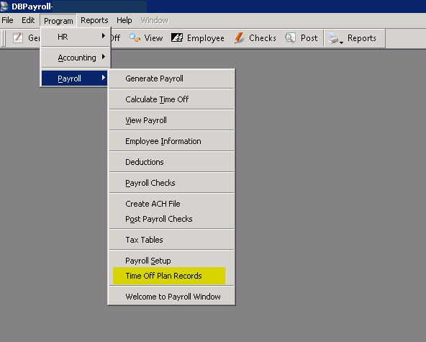

There are three types of Time Off Plan Set ups available.

First the Accrual Plan
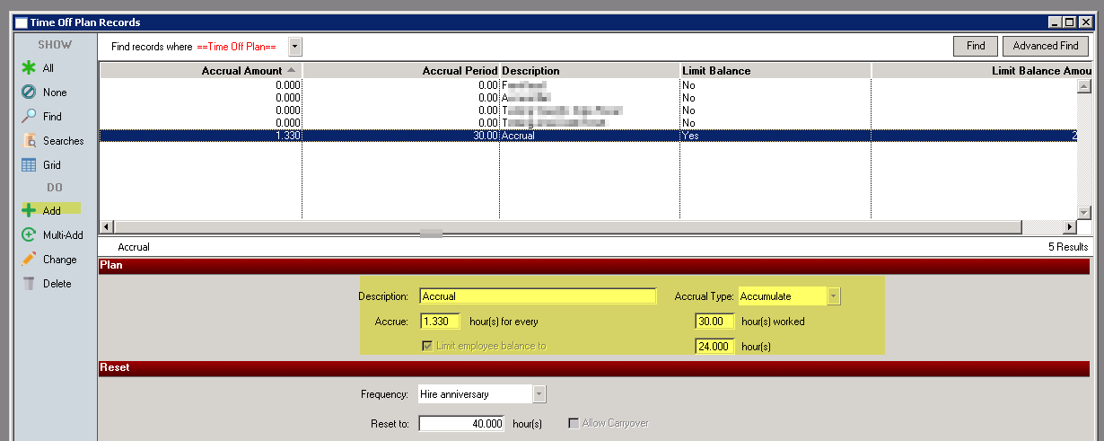

The Accumulate Plan accrues and uses hours based on the Pay Items selected. In the shown example, 1.33 hour of Sick Time would accrue for every 30 hours worked with a maximum of 24 hours allowed.
Hours that should count towards this accrual need to be check marked in the “Accrual” column. Common ones used are Salary, Regular, TC Hours etc. Check all pay items that show regular, worked hours for your company.
In the “Uses” column, check mark the pay item corresponding to the Time Off plan being created. Check all “Sick” pay items for a Sick Time Off Plan, all “Vacation” pay items for a Vacation Time Off Plan, etc.

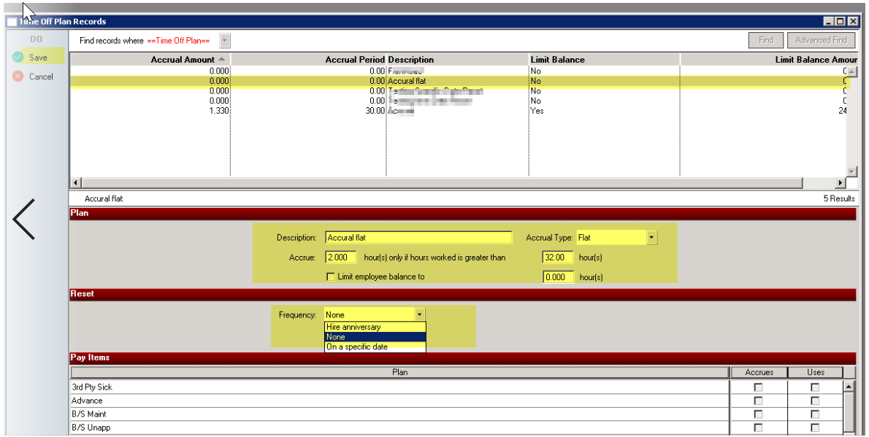

The Accrual Flat accrues time as hours are worked IF hours worked are greater than the minimum chosen. In the shown example, 2 hours of Sick Time would accrue for that pay cycle with no maximum. If only 20 hours are worked for that pay cycle, no hours will accrue.
Hours that count towards this accrual are Pay Items that will be used to accrue sick time Salary, Regular, TC Hours etc.
Hours that use the accrual are Sick.
So, if an employee works 40 regular hours in a payroll, they would accrue 2 sick hours which are automatically added to the employee’s information.

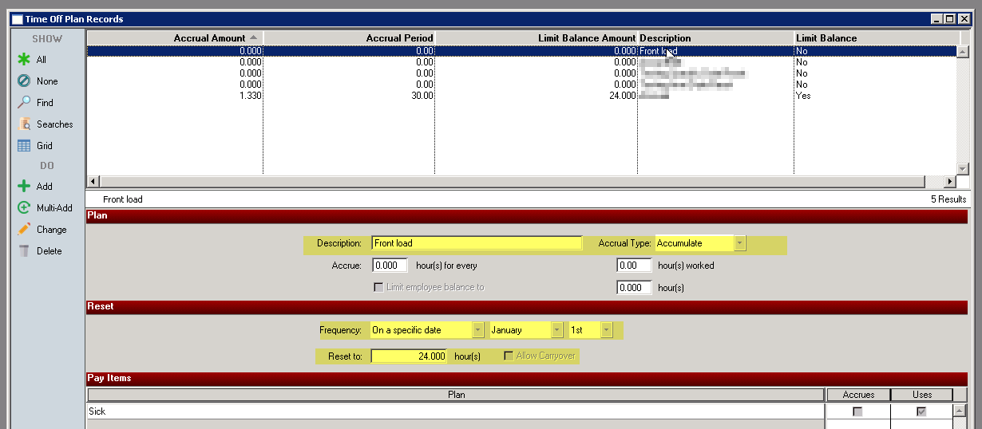

The Front Load is the most commonly used Time Off Plan. In this method hours are given on a certain date either Anniversary Date or January 1.
Here only the “Uses” column is used, check mark the pay item corresponding to the Time Off plan being used.
So, if an employee is given 24 hours sick time. They use 8 hours of sick time, they will have 16 hour balance until the end on the year.

Setting Up an Accrual Plan

Each Accrual Plan must have its own dedicated Pay Items to accrue hours. Examples
Reg = No Sick Time Accrual
Reg-24 = Accrues up to 24 Sick Time hours
Reg-40 = Accrues up to 40 Sick Time hours
The same applies for the Sick Time Pay Items to use accrued hours.
Note- New Pay items will need to be created to accommodate Accrual Plans. These new pay items should have the same expense accounts as the original. They can be named anything but should be recognizable, so they can be easily assigned to the proper Accrual Plan and employee setup.
Determine which pay items should count towards accruing hours. Generally Hourly, Overtime, Double Time, School/Training, WIP, Unapplied Time, etc. hours would all count. It is up to your company to decide what employee worked hours should count towards the accrual. Create the new Pay Items. Once all pay items have been created, open the Time Off Plan Records.

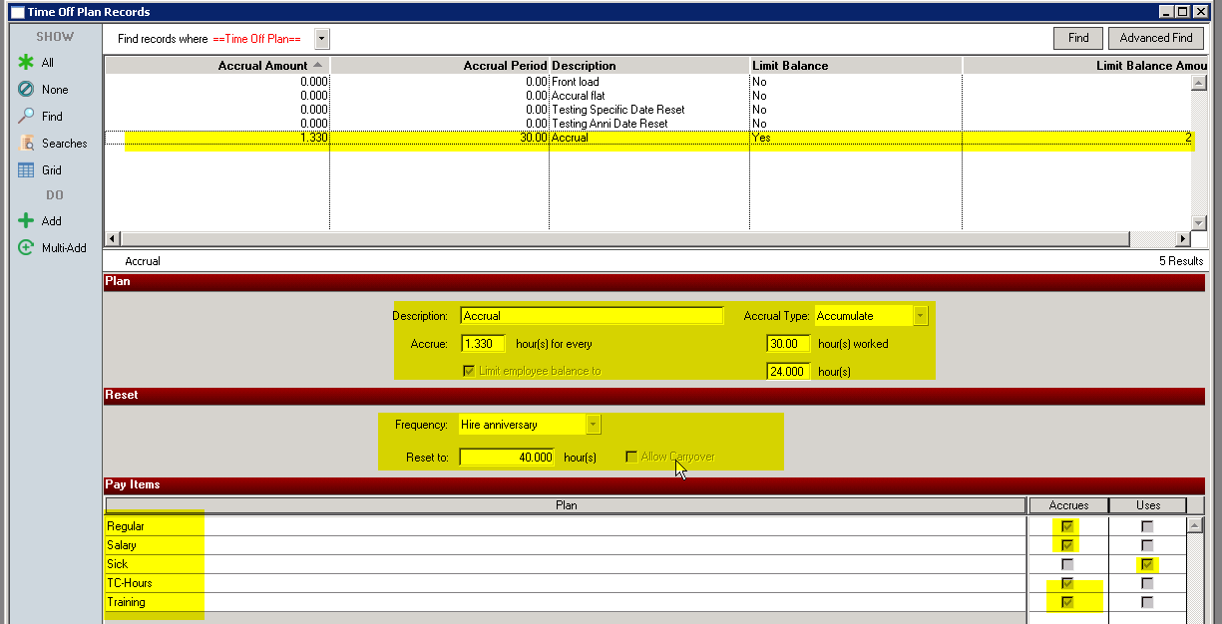

Choose how hours will Accrue (Example- 1.33 hour for every 30 hours worked)
Select Limit if the accrual plan has a maximum number of hours allowed.
Checkmark every Pay Item the plan should Accrue hours on.
Checkmark every Pay Item that will Use this plan’s accrued hours.

Save.
Now add the required Pay Items to each Employee who needs the accrual plan. Following the examples on this manual, if an office employee needs a Sick Time Accrual Plan that accrues to a maximum of 24 hours, they would receive the Pay Items Regular, Salary, TC-Hours, Training, and Sick.
Make sure their hourly pay item is check marked to Always calculate when generating payroll.
Add in their hourly wage.

Salaried employees should also have an hourly pay item. They can have hours added without a wage being calculated.
Example: Salaried employee with Pay Items for salary pay and hours. This employee will automatically have $3000 and 80 hours pulled onto every payroll. They are on the 40-hour accrual plan, so will accrue 1.33 Sick Time hours per payroll, with a maximum of 24 hours able to be accrued.
There are no changes to generating or processing a payroll.
Accrued hours will show on each employee, under the Time Off Plans tab. Hours can be added or removed with the Add Accrual or Add Usage buttons if needed. These may also be Deleted however, it is a permanent delete.

Loading Hours to an Employee

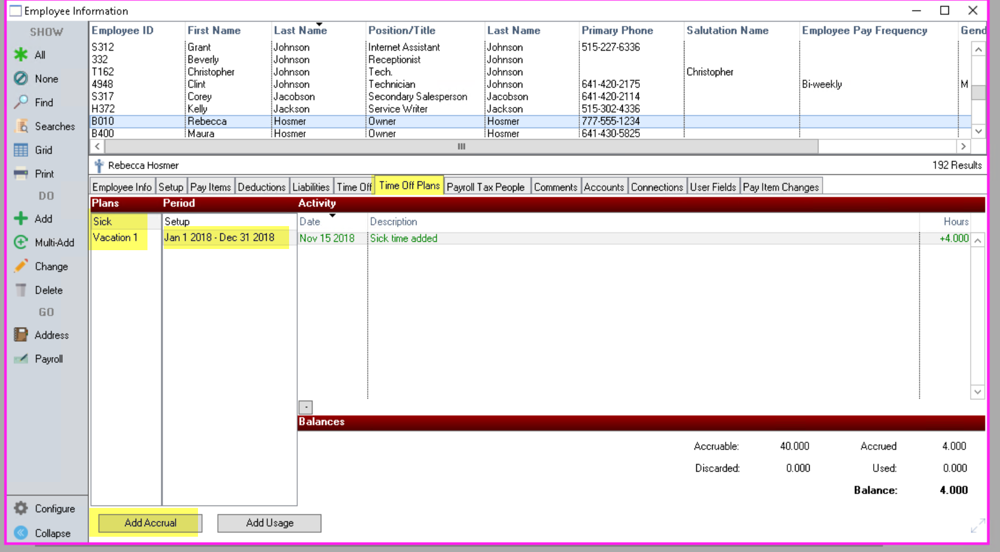

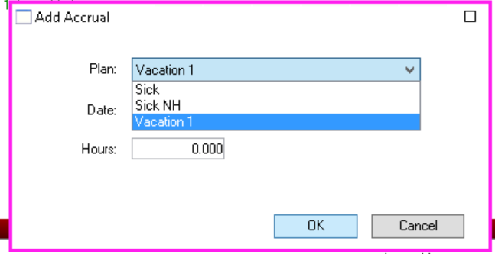
*DO NOT CLICK ON CHANGE
In the Employee Information screen, Time Off Plans tab, click
on the “Add Accrual” in the lower left corner.
Pick the Choice of Plan, Dates, Hours. OK

You may remove something done in error, however, it is a permanent delete. You do this by Clicking the minus (-)
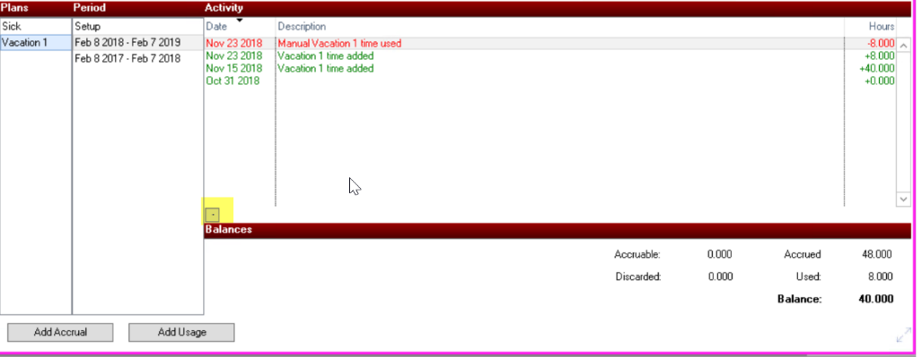

Employee's balances can be print on their pay stubs. Please contact DealerBuilt Payroll Support for the balance to be put on employee stub or for any Time Off Plan question.

