Dealer Docs User Guide 10.1.23

1) Dashboard Access and Navigation:

1.1) Accessing Your Dashboard:
To access the Dealer Docs dashboard, simply click the button labeled “Docs” on your LightYear menu bar:
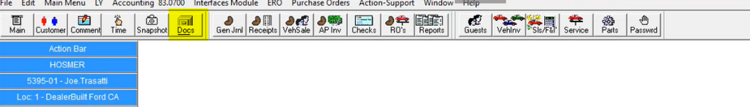

1.2) Navigating The Dashboard:
Once your dashboard launches you will see various default widgets which have been configured for your specific role in the organization.
As seen in the examples below, common dashboard widget functionality includes: Document Search boxes (1), Scan/Upload prompts (2), Document Lists (3), Charts and reports (4)
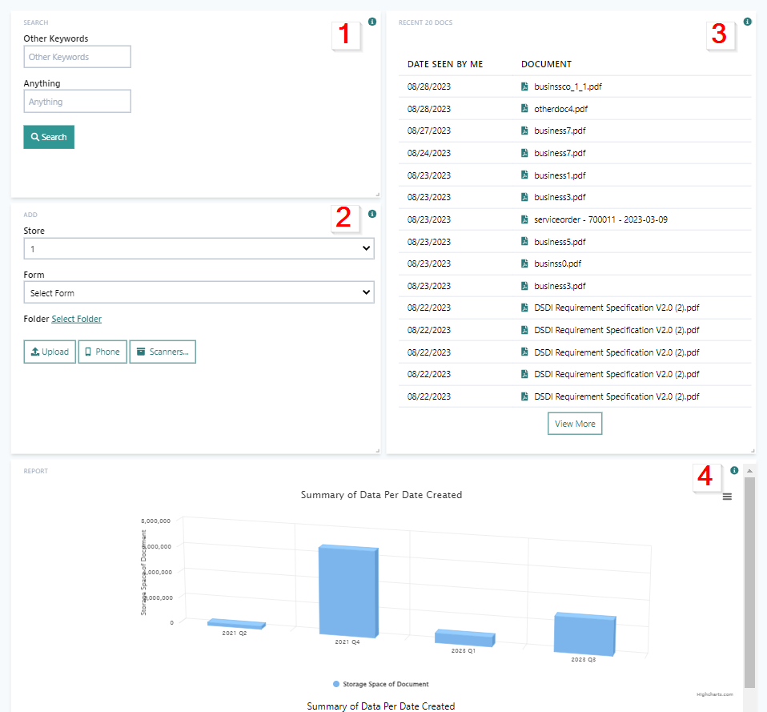

2) Dashboard Customization (Advanced):

2.1) Add New Widgets:
- To add widgets to your dashboard,
1) click the gear icon in the bottom right corner of the dashboard screen and
2) Click “+ Add Widget”,
3) Then select the type of widget that you would like to create. 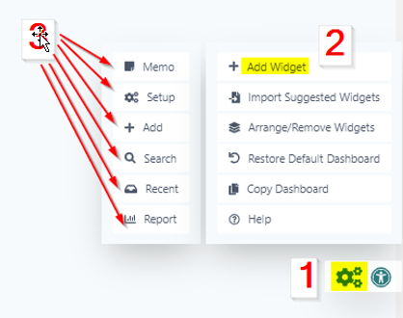

- There are 6 different types of widgets that can be added to the dashboard:
- “Memo” Widget - This is a static text field that will display on the dashboard, users like to use this as a reminder or sticky note
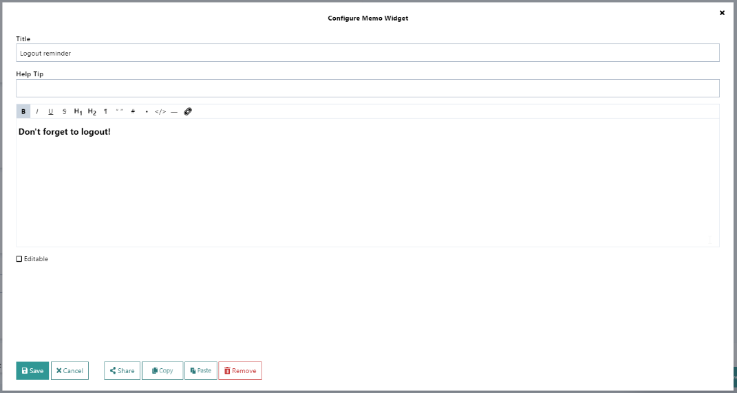
- “Setup” Widget - If your role requires you to look at a list of users, roles, folders, forms or stores frequently, you could use a setup widget to identify the list type and add to the dashboard
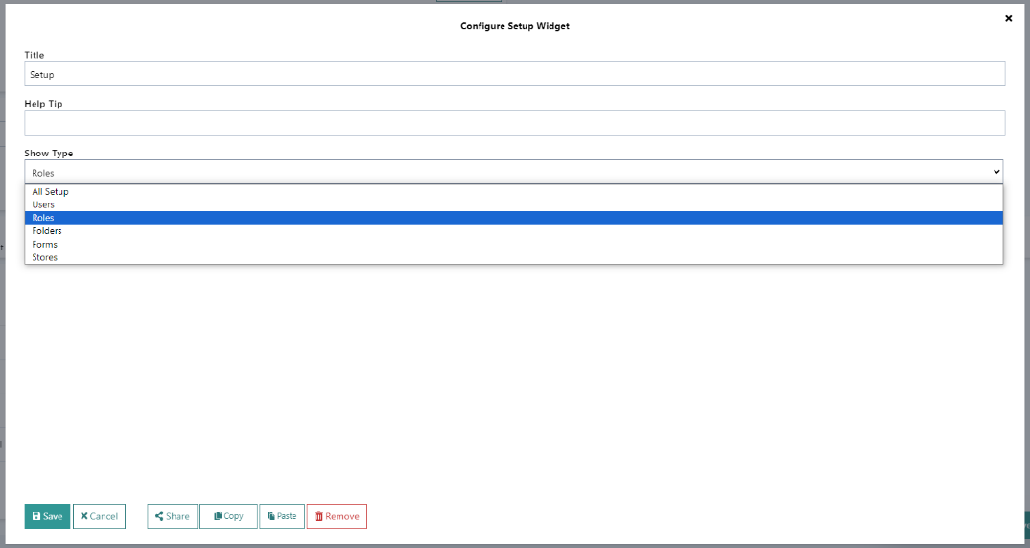
- “+ Add” Widget – Used for document upload/scanning, the Add Widget will let you do different types of things such as upload from a directory or scan from phone or scan from scanners. If you are going to be doing a lot of scanning of particular document types, you may want an “+ add” widget.
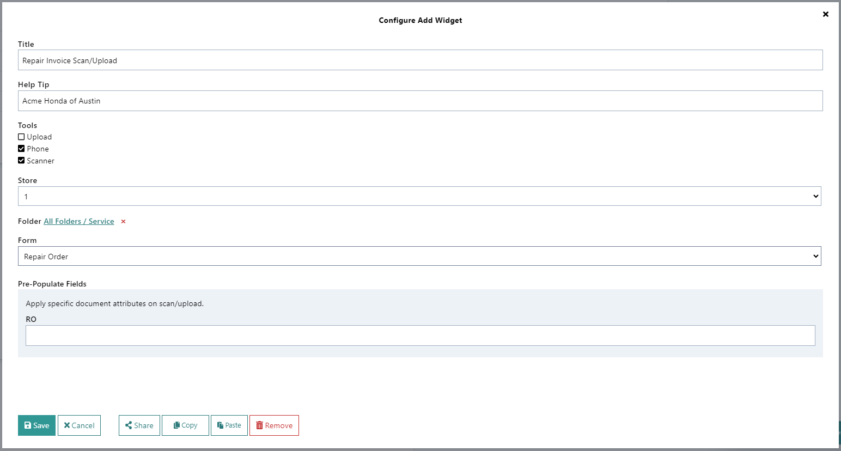
- “Search” Widget – Create a custom search to allow legacy imported data and new data format or any commonly searched information in a single search field.
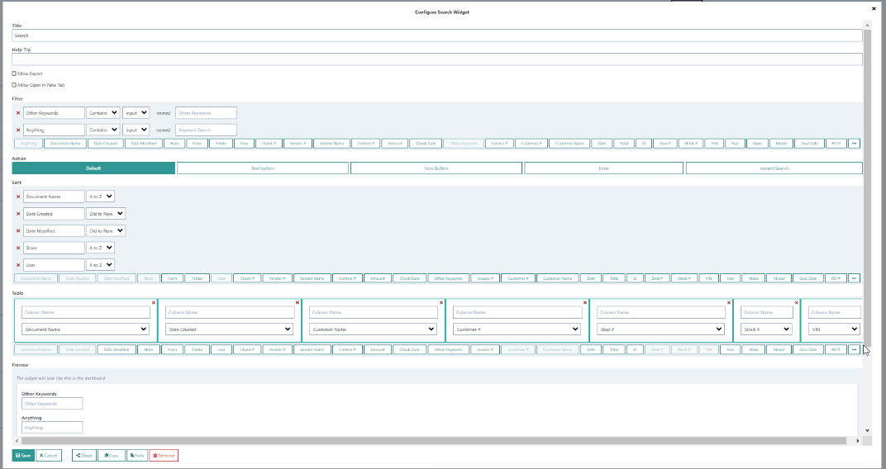
- “Recent” Widget – Easily find documents that you have recently created, edited or viewed. Set criteria for flagging recent docs and date range for query.
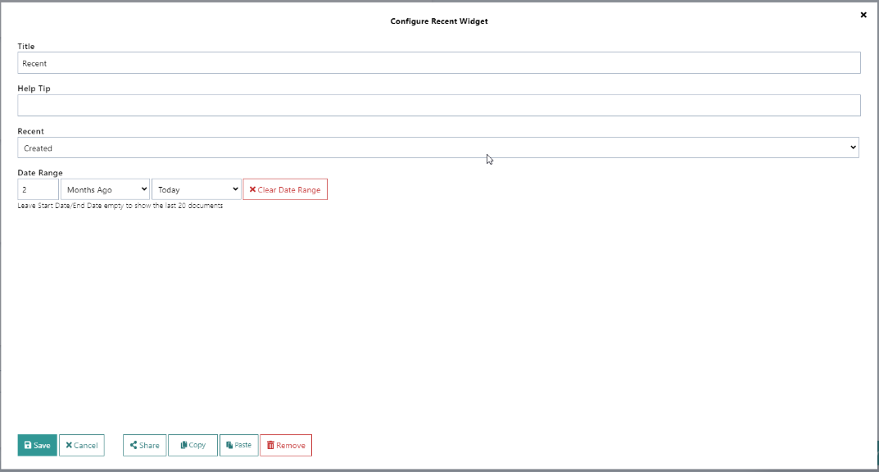
- “Report” Widget – If you are a user that likes to monitor overall activity you can use the Report Widget to create a variety of custom reports in different presentations such as: pie charts, bar graphs, and table listings.
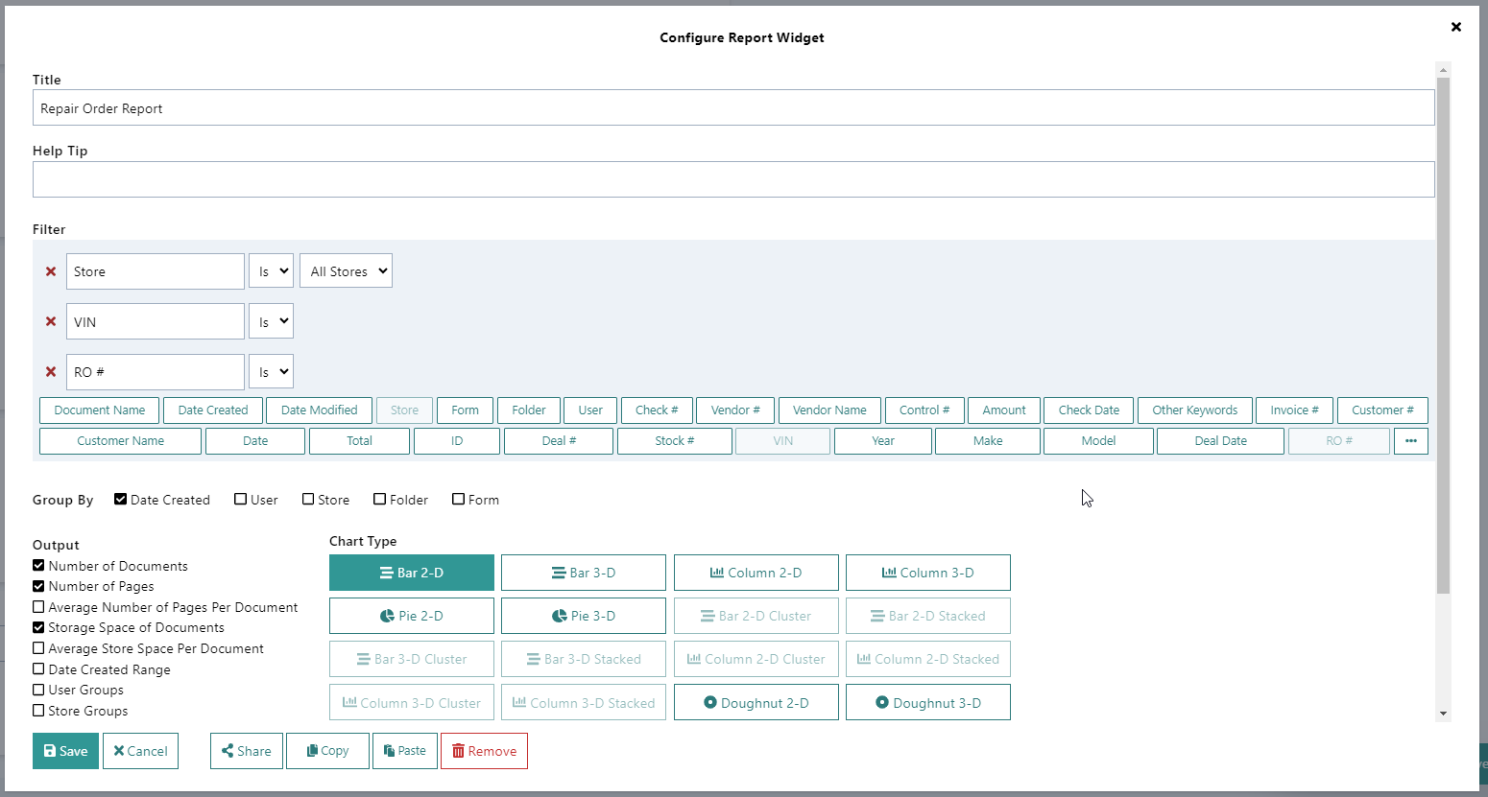

2.2) Edit existing widgets:
The dashboard widgets are highly customizable for each user. To edit existing widgets, click the gear icon in the bottom right corner of the screen and click “Arrange/Remove Widgets”, then select the configure button in the top right corner of the widget box as seen in the screenshot below:
