Password Reset
Go to https://oplogic.com/, click on Log In (on the top right of the screen).
- It will take you to the log in page where you can select Forgot Password
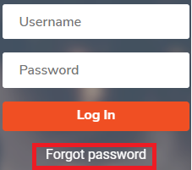
Enter your username to retrieve your password. (Your username is most likely your first and last name as one word, without spaces and it is not case sensitive). Hit Reset.
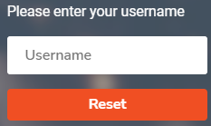
An e-mail will automatically be sent to the e-mail linked to your username.
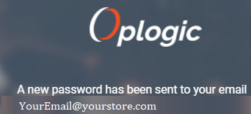
If your listed e-mail is incorrect, your manager can update your profile. If you need assistance, please refer to Update profile information
If the message does not appear in your inbox, please check junk/spam.

