Password Change
Once logged in select the Preferences option on left side of screen. You may have fewer/more options than listed.
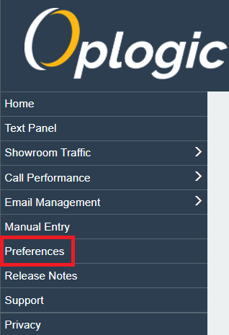
Select Change Password at the top of the screen
Use the form to create a new password
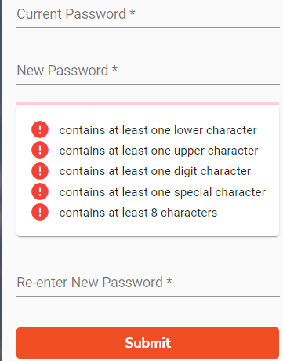
NOTE: All passwords must be a minimum of eight (8) characters in length, include an upper case, a lower case, a number, and a special character.

