Auto-Authenticate from the App
- Once logged into the app, click on the hamburger:

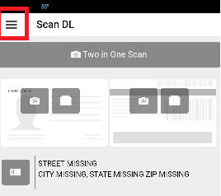
- Click on SETTINGS
- Scroll down and you will see AUTHENTICATION DEFAULT
