Create an e-mail/text template
NOTE: Some dealerships require Manager/BDC access in order to perform this function
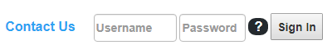
You will need to log into Oplogic at http://www.oplogic.com/.
Your username is always your first and last name, as one word, without spaces and it is not case sensitive.
Once logged in:
Select the Preferences option on left side of screen. You may have fewer/more options than listed.
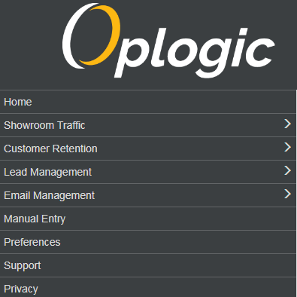
Scroll to the bottom of the page and select Customize E-mail (or Texting) template
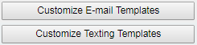
Customize E-mail
You can create a new template or modify an existing template
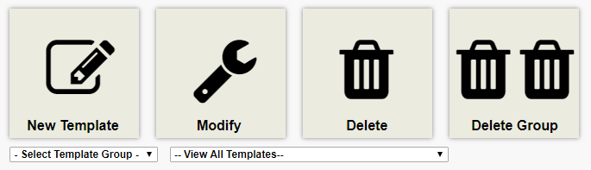
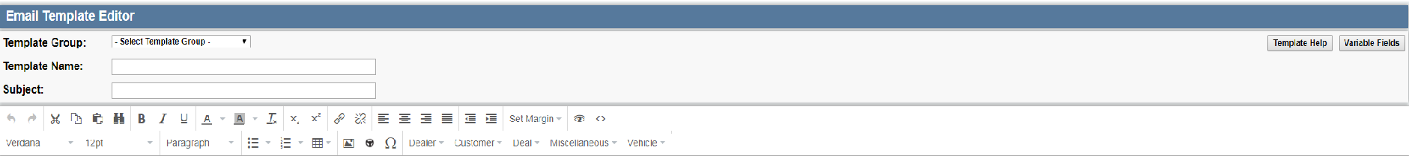
If you select New Template, it will take you to the Email Template Editor.

Create an e-mail/text template
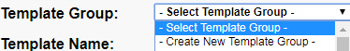
You can add this new template to an existing group, or create a new group.
Create a name for your Template
Write a subject line you will want all recipients of the e-mail to see
Create the body of the e-mail.
You have access to variable fields that will auto-populate in the e-mail , you can find them here:
or
Sample e-mail template:
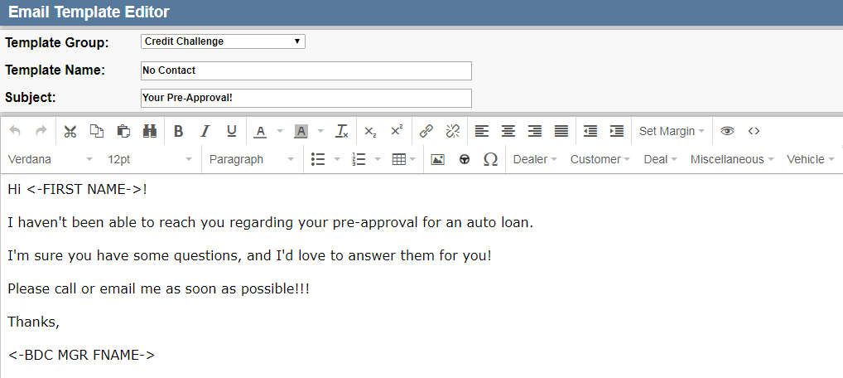
<-FIRST NAME-> will be replaced by the first name of the customer
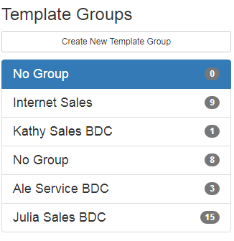
<-BDC MGR FNAME-> will be replaced with the BDC manager’s, linked to this customer, first name

Customize Text:
You can create a new template, top right of screen, or edit an existing one.


Create an e-mail/text template
Sample Text Template:
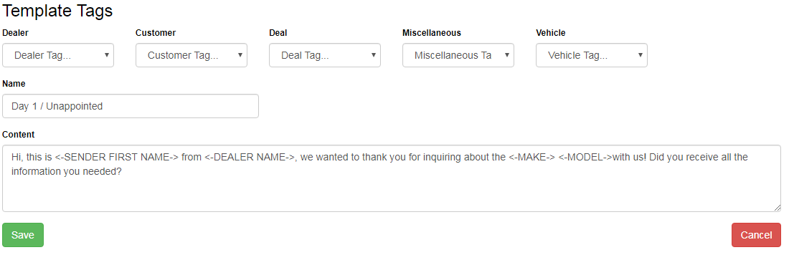
<-SENDER FIRST NAME-> will be replaced by sender’s first name
<-DEALER NAME-> will be replaced with the Dealer’s name
<-MAKE-> will be replaced with the vehicle make
<- MODEL-> will be replaced with vehicle model

