Create an e-mail template using HTML
- From your browser Copy Source code
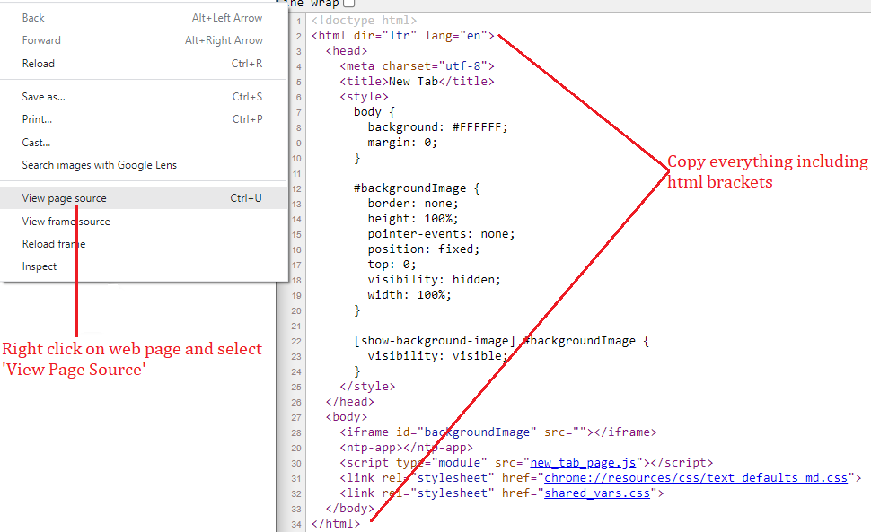

- In Oplogic Go to Preferences > E-mail Templates > Customize E-mail Templates
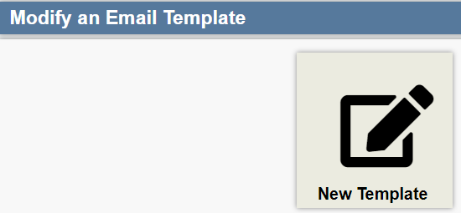
  - Select New Template

  - Paste Source code and complete entering Template information
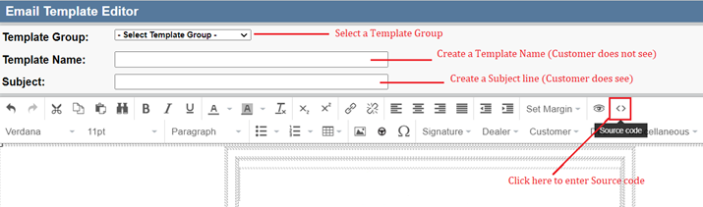

- Verify everything looks good and save

