Create a text template
NOTE: Some dealerships require Manager/BDC access in order to perform this function
- Select the Preferences option on left side of screen.
- Scroll to the bottom of the page and select Customize Texting template

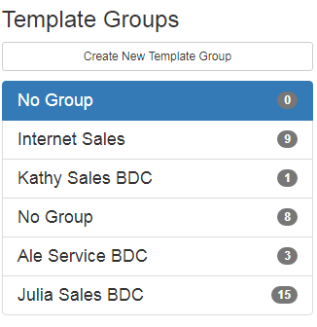
Customize Text:
You can create a new template, top right of screen, or edit an existing one.


- You have access to variable fields that will auto-populate in the text

Sample Text Template:
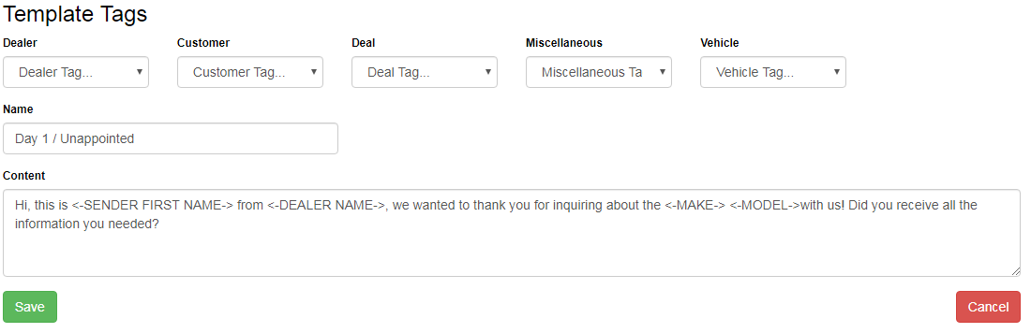
<-SENDER FIRST NAME-> will be replaced by sender’s first name
<-DEALER NAME-> will be replaced with the Dealer’s name
<-MAKE-> will be replaced with the vehicle make
<- MODEL-> will be replaced with vehicle model

