**Credit Applications via text/email**

* Once in a lead, scroll down to **File Uploads/Credit Application.**

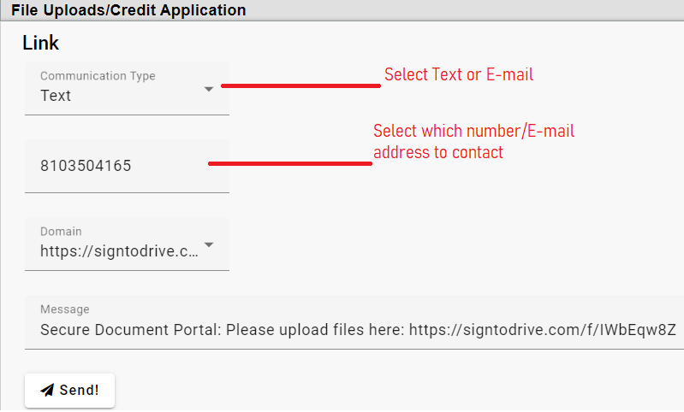

* Select ‘Text’ or ‘E-mail’ and the number/address to use. Click ‘Send’.

CAUTION! Typing in a phone number or E-mail address of someone else will link their responses to this profile and override data already entered!

* If you need information from a co/buyer, switch to that Profile and repeat the above steps. Do NOT just change the phone number or E-mail in ‘File Uploads/Credit Application’.

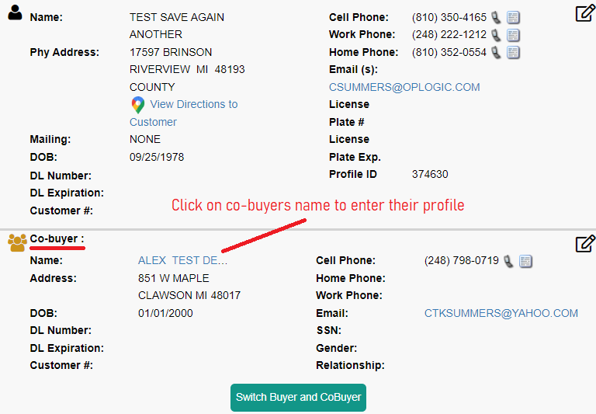

* They will receive a text/e-mail like this:  
    
  