Customer Search
Option 1:
Use the search field at the top of the screen.

You can use either the customer name, a telephone number, a deal number, a stock number, or a GM Lead ID.
Option 2:
Select Showroom Traffic from the left menu then select Customer Search under the Customers heading.
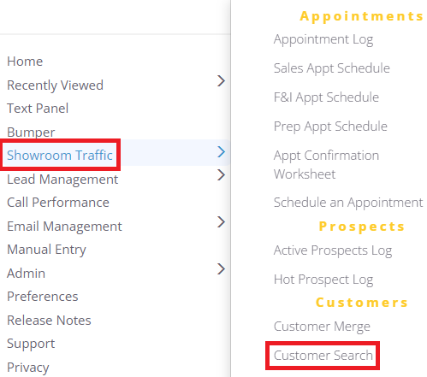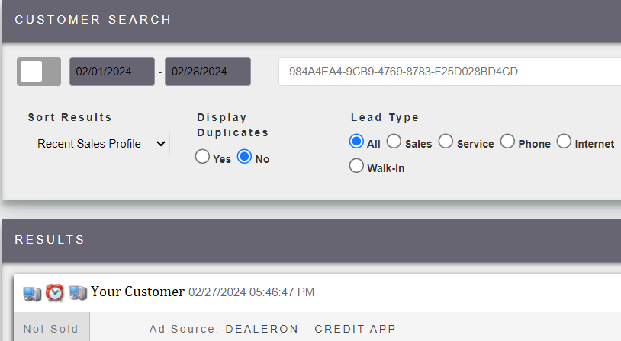

What if I cannot find them?
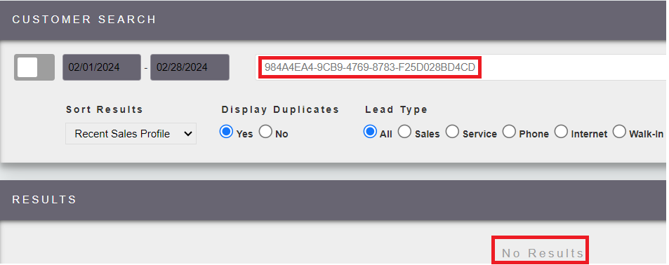
The customer may have a duplicate/merged/co-buyer profile. You can either click on the ‘advanced search’ button , from option 1
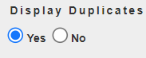
Or select the option to show duplicates in option 2.

