E-mail Campaign

* Select Build E-mail Campaign.

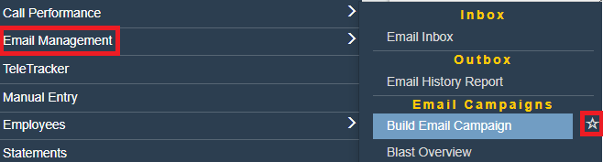

* + 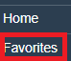Clicking the star will add this to a ‘Favorites’ Tab for quick access
* Set your filters.
  + For example, if you wanted leads from May 1st until today that were not sold/delivered. You would make changes to the highlighted areas.

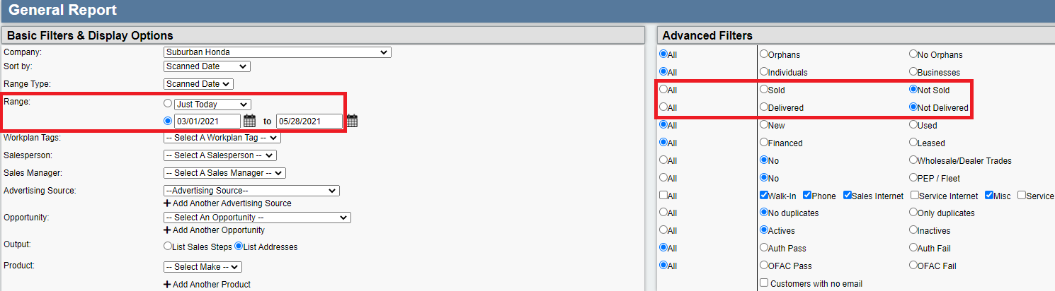

* On the results page select the airplane 
* Compose your normal e-mail (templates are recommended)

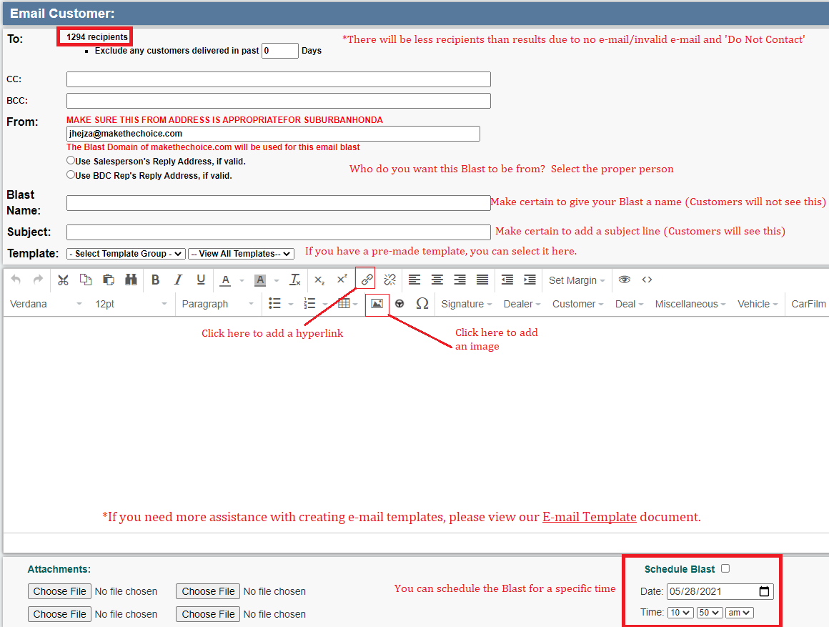

* A manager will need to approve the blast