Handling leads
Use the dashboard (top right of screen)
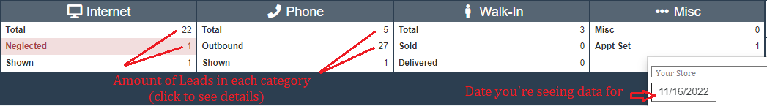
Once you click on a number to see the leads, you’ll see something like this: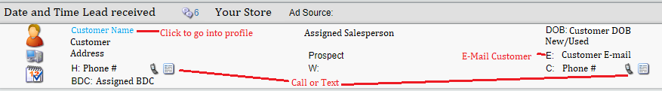
Once you click on a Customer, you’ll see their profile:
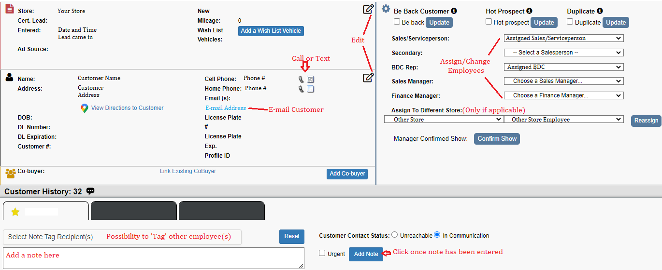
To remove leads from ‘Neglected’ you can do any of the following:
-Call or text customer from Oplogic
-E-mail customer from Oplogic
-Add a note to their profile

