Internet Lead Dashboard
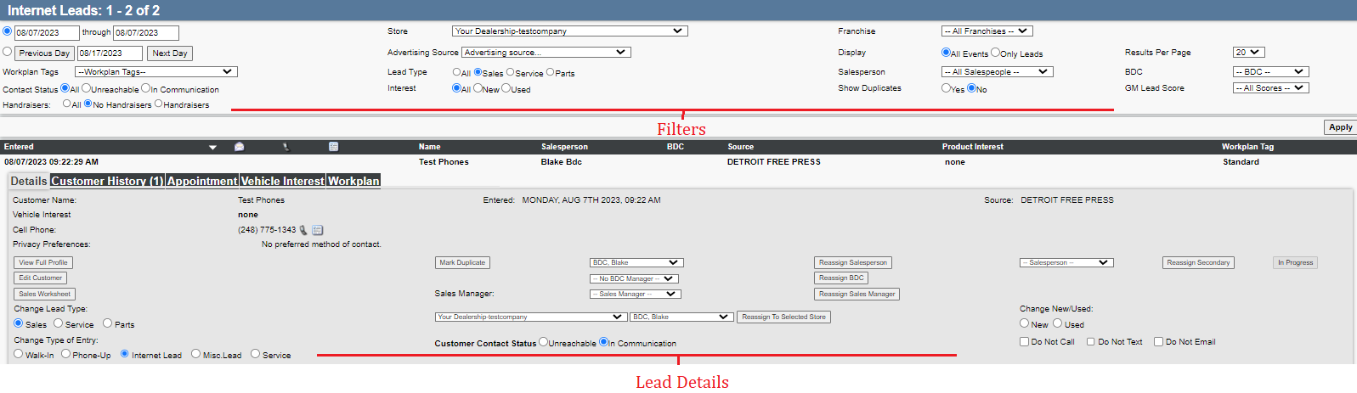
- Ability to see and add to Customer History.
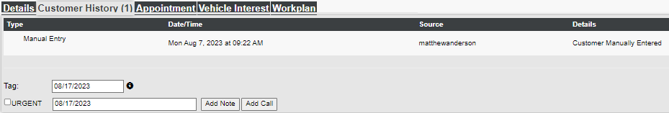
- Ability to Make Appointments.
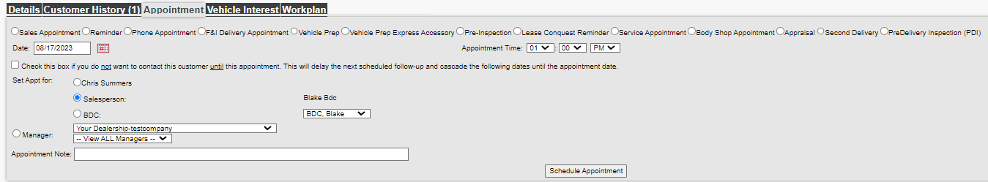
- Ability to see and change which workplan (with follow-ups) the lead is on.
