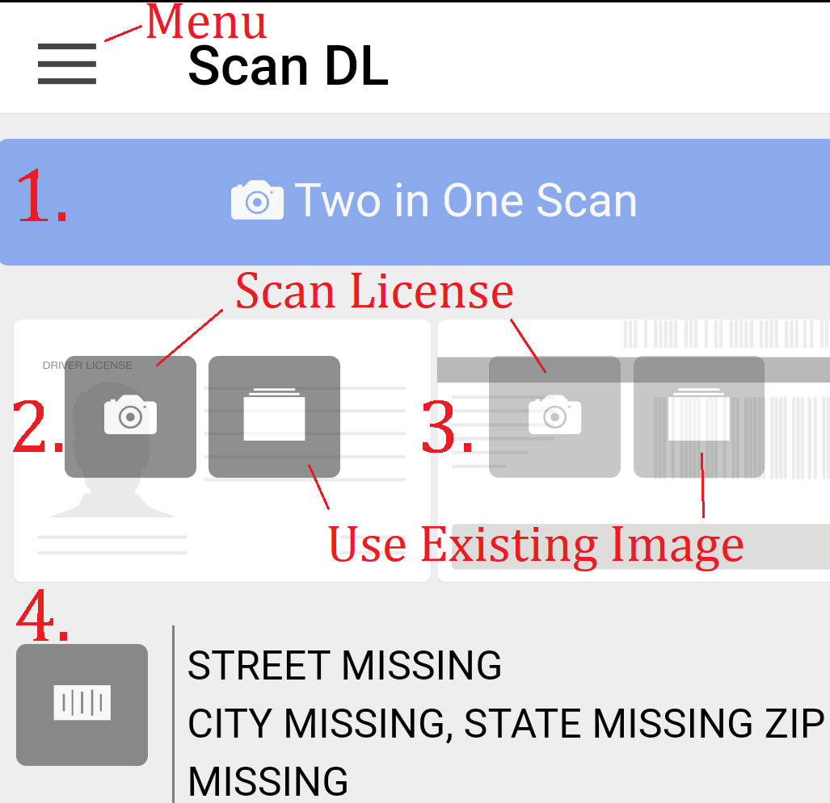
Mobile App

1. Scan Front and Back including barcode (most accurate)
2. Scan Front of License
3. Scan Back of License
4. Scan Barcode on back
- When you are done scanning, click NEXT
  - Verify Information is Correct
  - Possibility to add
Trade-in, Phone Number(s), E-mail, Vehicle of Interest, SS #
- You will need to add
Salesperson and Ad Source

When you click Finish, the system will check for duplicates and show you a list if any exist. You can either click an existing lead (this will merge the 2 together) or you can keep this lead independent.
Select Menu
Option to Search for a customer, look at your workplan, view your e-mails and texts via Oplogic, and view appointments.
When in a customer profile you can:
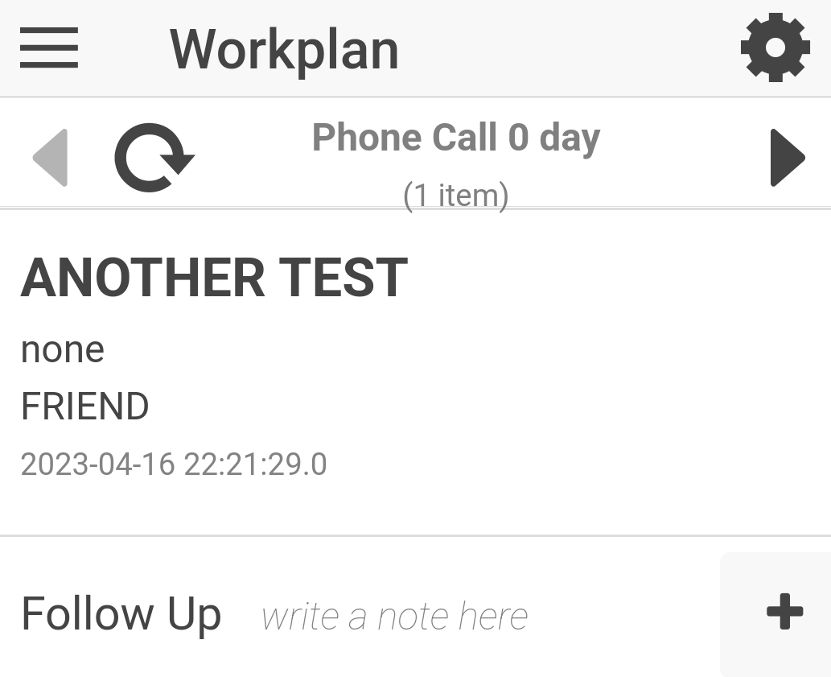
Create an appointment, add a trade-in, text/call/e-mail, add a note, view future workplan items, view customer and sales history
Stop the clock by adding a note, sending an e-mail/text, calling, or completing workplan item

