Creating 2 Vehicle events for 1 customer (multiple purchases)
Once you have your first lead, regardless of source (Phone, Internet, Walk-in, Misc) with a vehicle of interest added, you will need to create a manual entry for the customer and their second vehicle.
This can be a license scan or an actual manual entry.
If you scan a license, do not have the system merge the profiles.
For a manual entry:
Use the Match Existing feature to auto-populate customer information.
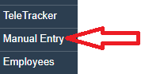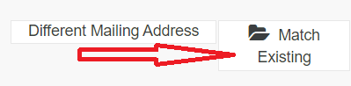
Type in some customer information (i.e. Name or Phone Number) and click Match Existing to try and find the customer. Once results populate; Select the radio button in front of the correct customer.
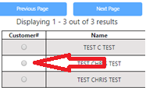
Alternately you can enter all the information manually.
Make certain you select an Ad Source and specify the type of lead. You can add the Vehicle of Interest from here as well.
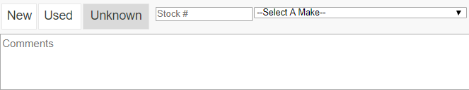
Now there will be 2 associations on file, each showing the different vehicles that can be worked independently

