Remove a lead from Neglected Status
Use the dashboard (top right of screen), Click on Neglected
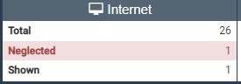
Takes you to more detailed screen: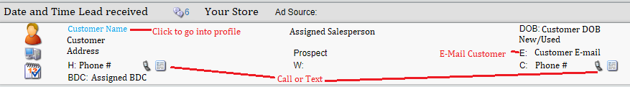
Once you click on a Customer, you’ll see their profile:
-You can Call, Text, or E-mail
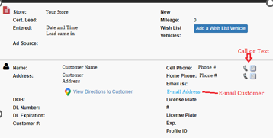
-You can enter a Note:
To remove leads from ‘Neglected’ you can do any of the following:
-Call or text customer from Oplogic
-E-mail customer from Oplogic
-Add a note to their profile

