Mobile App
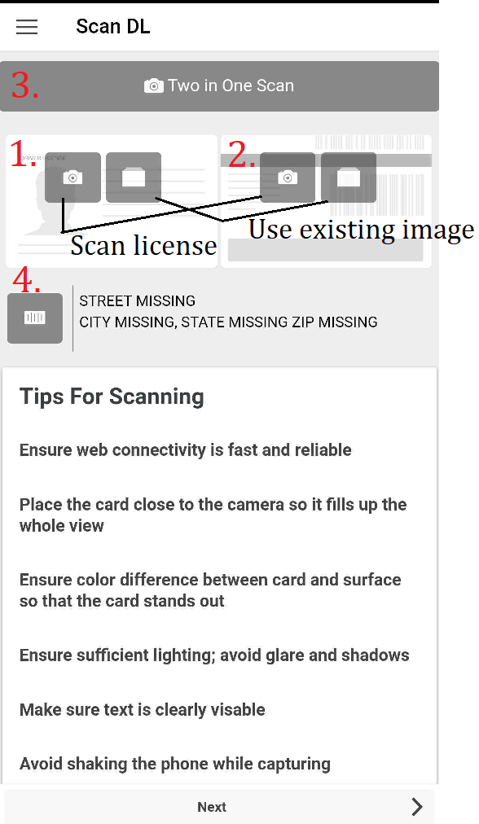
- There are numerous ways to scan a license:
- Front of License
- Back of License
- Scan Front and Back including barcode
(MOST ACCURATE)
- Bar Code on back
- When you are done scanning, click NEXT
  - Verify the information is correct
  - Possibility to add:
    - Trade-in
    - Phone Number(s)
    - E-mail
    - Vehicle of Interest
    - Social Security Number
  - You will need:
    - Salesperson
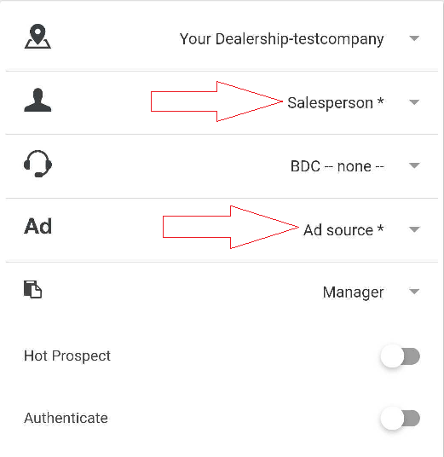
    - Ad source

- When you click Finish, the system will check for duplicates and show you a list if any exist. You can either click an existing lead (this will merge the 2 together) or you can keep this lead independent.

