Texting from the App
- If you do not have the App installed yet, you can find it at the play/App store
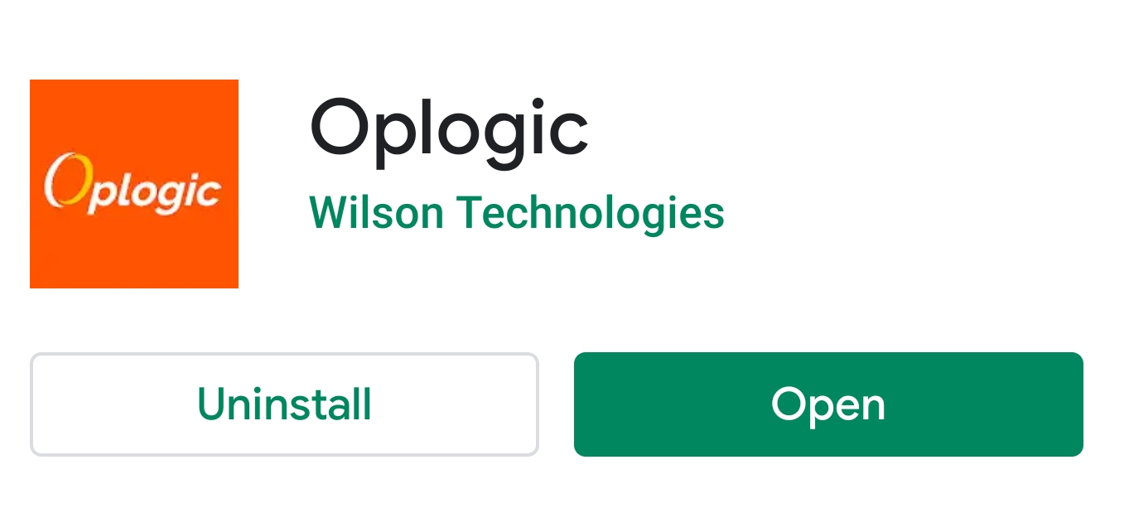
- When you open the App, you need to select the menu
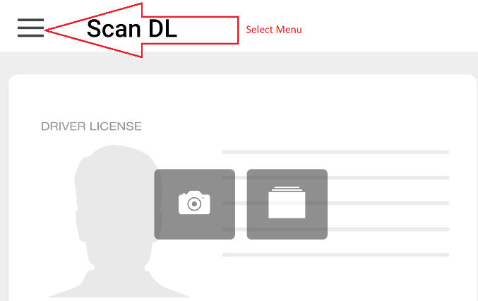
- To find a customer, you can search or use your workplan
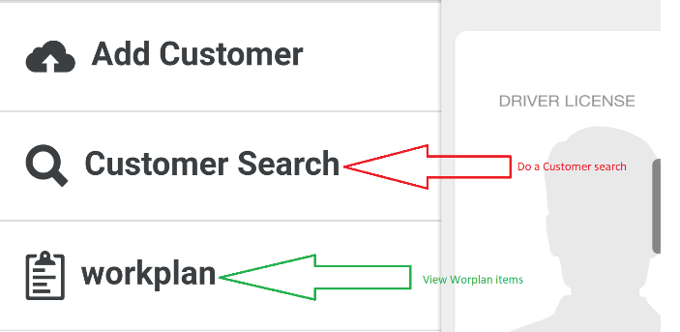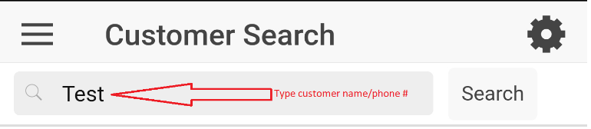
- Once in the customer profile, scroll down until you find contact Info/Outbound
  - Select the Text option
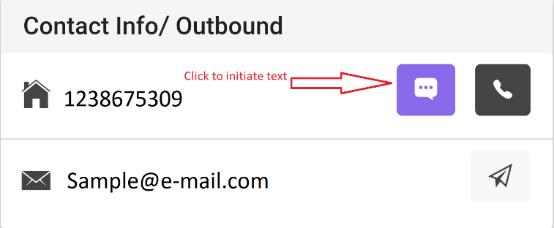
- If the customer is ‘Do Not Text’ or no phone number is listed on their profile, there will be no option to text.
- If the customer says they never received a text, make certain the number is a valid cellphone number.

