Update Employee Profile
You will need to log into Oplogic at https://oplogic.com/.
Once logged in:
Select the Preferences option on left side of screen. You may have fewer/more options than listed.
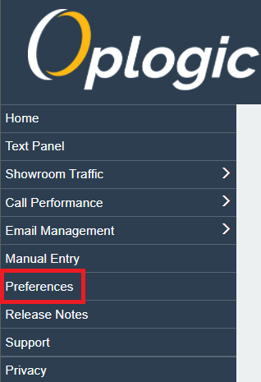
Update the needed information
