Work Plan
- Work Plans only load when clicked to prevent time-out/proxy errors and speed up load times
  - First category loads automatically
- Grouped by category and sub-category
- Search bar
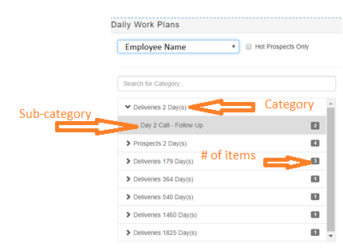
- Ability to Expand and Collapse all fields
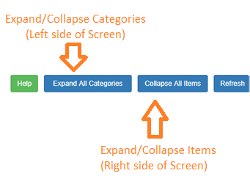
Items
