To Download Aatrix for 1099 E-Filing

- https://www.aatrix.com/aatrix-wefile/1099-efiling/?#gf_7
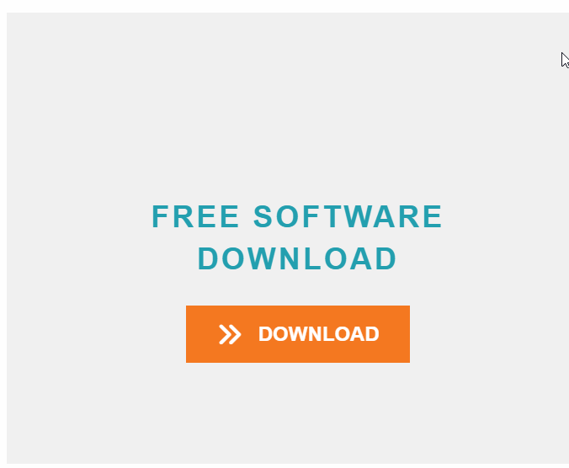
- Select the Free Software Download

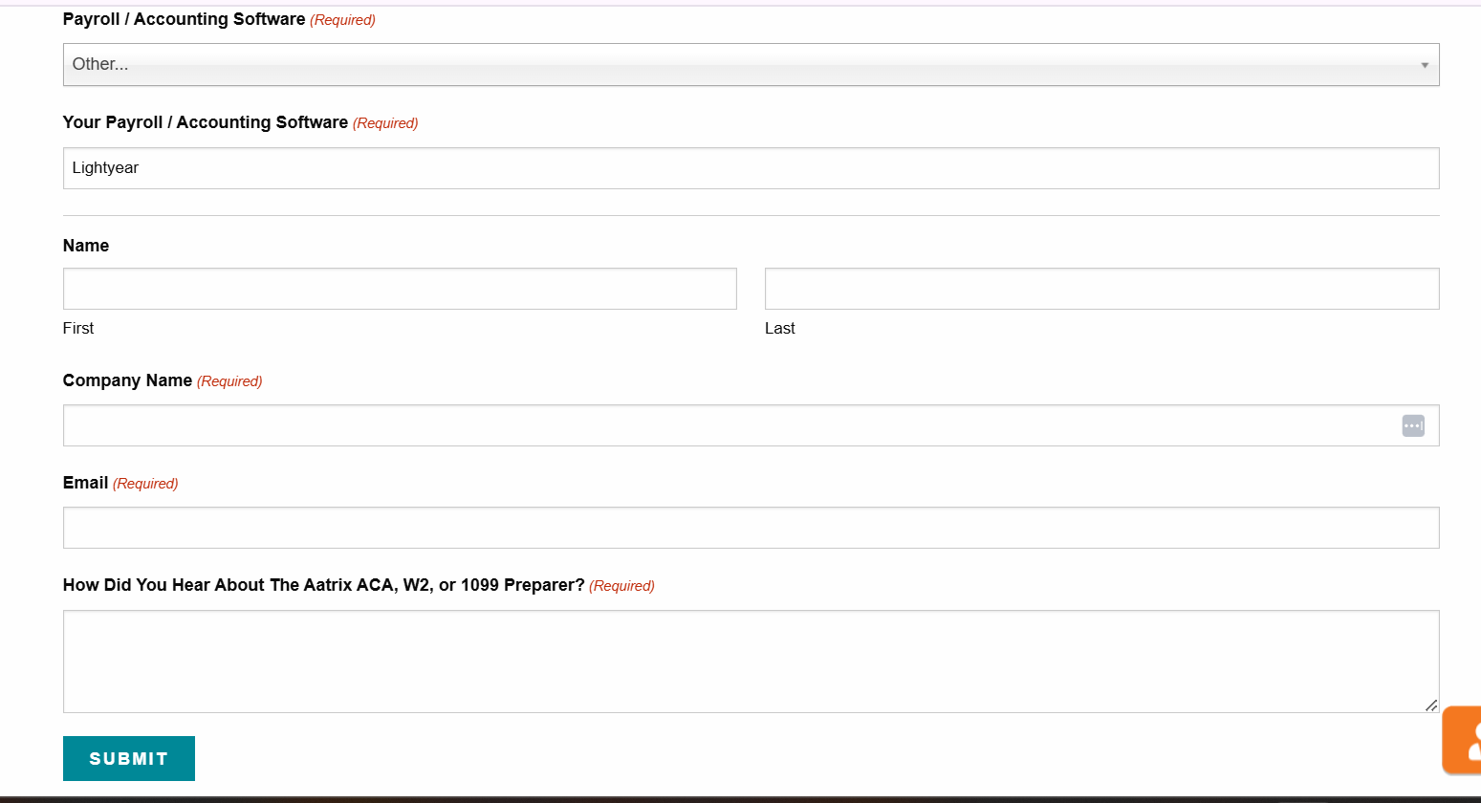
- Enter the information in the fields below, select Other for the Payroll/Accounting Software and type in Lightyear and click submit.

- Download the program
