How to Scan Documents Using Document Management

Selecting Store, Form and Folder
- In Lightyear, go to the Docs tab to open Document Management

- Select the Store you want the documents to scan to
- Click Form and choose the correct department.
- Click Folder and select the folder that applies.
  - If a subfolder is available, choose the one that fits your needs.
- Once you have made your selections, click the Scanner.
⚠️ Important: Scan Agent must be installed on Local Computer and if no scanners are available it will say “NO SCANNERS”

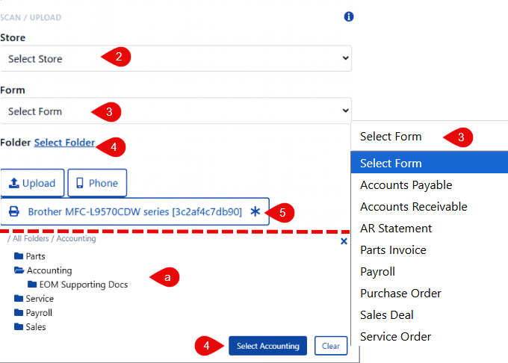

Scanning with a Connected Scanner

Standard Scanning
• Make sure the Scan Agent is installed—this allows scanners connected to your computer to appear.
• Load paper into the scanner and click the scanner you wish to use.
- The image below shows multiple scanners available; however, your setup may be different depending on how many scanners are available on your local machine.
- The Asterisk next to the scanner indicates your default scanner
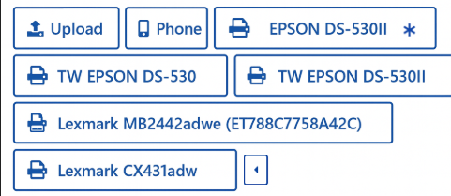

Barcode Scanning

• Some forms, such as the Deal Recap, contain a barcode.
• Place all related documents behind the barcode form and scan them together.
• The barcode automatically links all documents to the correct Deal or RO.
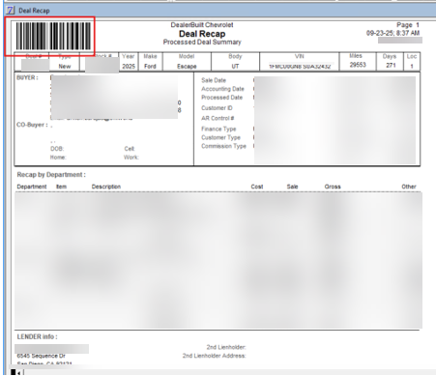

Scanning with Phone

- Follow the same stepS 2-4 in the selecting Store, Form and Folder Section
- Click Phone in the scanning menu.

- Scan the displayed QR code.
- Use your phone to scan and submit the document.
⚠️ Important: If the scan is not linked to a deal, you must manually enter details (e.g., deal number) in the right-side data fields. Otherwise, the document will be harder to locate later.

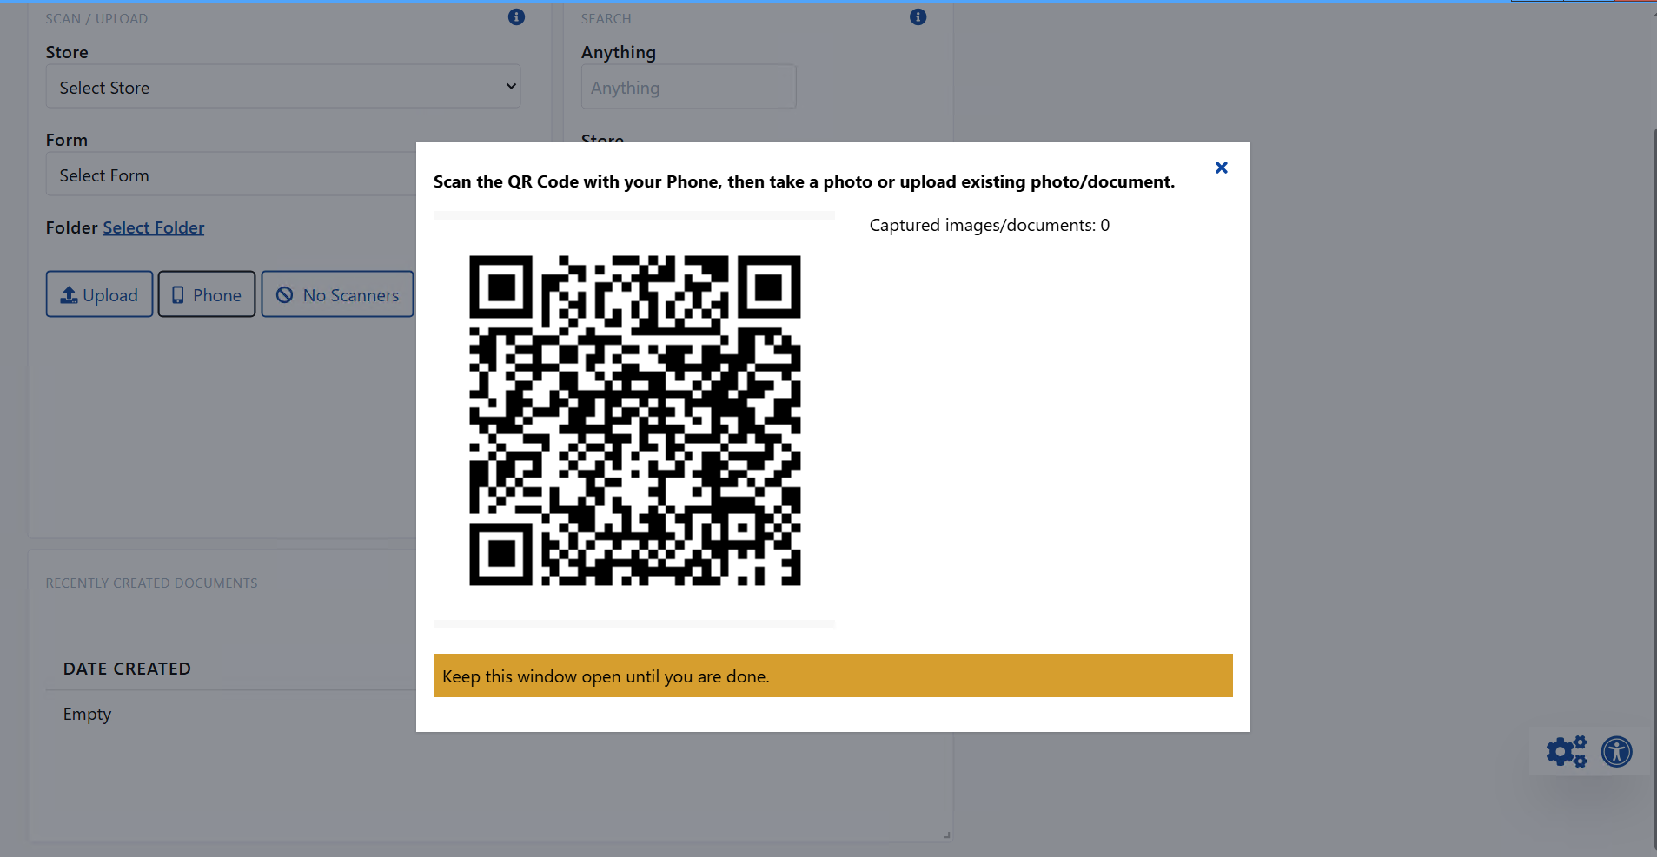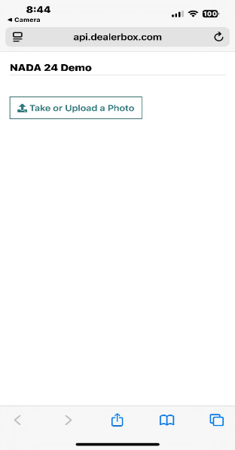

Uploading Documents

- Follow the same stepS 2-4 in the selecting Store, Form and Folder section
- Click Upload to upload a saved document.
⚠️ Important: Files must be saved to the DealerBuilt Desktop before uploading.

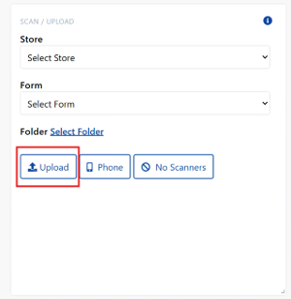

Scanning in Bulk

- Make sure that all documents are separated by a top sheet with a Barcode (e.g., RO, Deal Recap, etc.).
- Hover your mouse over the Scanner you are using.
- Make sure to select 'Barcode All Pages' – this ensures that each time a barcode appears during the scan, the metadata is updated and incorporated from the barcode.

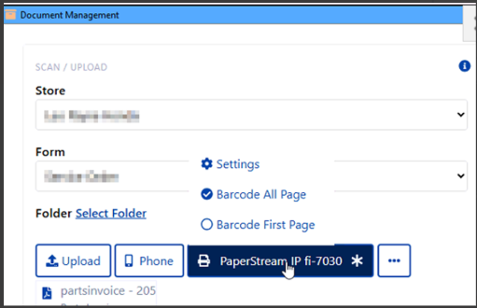

Search Documents

Use the Search widget to find stored documents. You can search by:
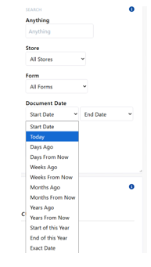
- Anything
- Store
- Forms
- Documents
- Folders

